Name: Nilanjan Ghosh

College: SRM Institute of Science and Technology

Course: Java FSE Digital Nurture

Week 1

Exercise 1: Setting Up JUnit
Aim
To set up JUnit in a Java Maven project and create a test class for performing unit testing.

Objective
The objective of this exercise is to configure JUnit in a Java project using Maven and verify the setup by creating and executing a sample test case.

Software Requirements
- Java Development Kit (JDK)
- Apache Maven
- Visual Studio Code / IntelliJ IDEA / Eclipse
- JUnit 4.13.2

Procedure
Step 1: Create a New Maven Project
A new Maven project named JUnitExercise1 was created using Maven Archetype.

Step 2: Add JUnit Dependency
The following dependency was added to the pom.xml file to include JUnit 4.13.2 in the project.
<dependency>
<groupId>junit</groupId>
<artifactId>junit</artifactId>
<version>4.13.2</version>
<scope>test</scope>
</dependency>
Screenshot 1:
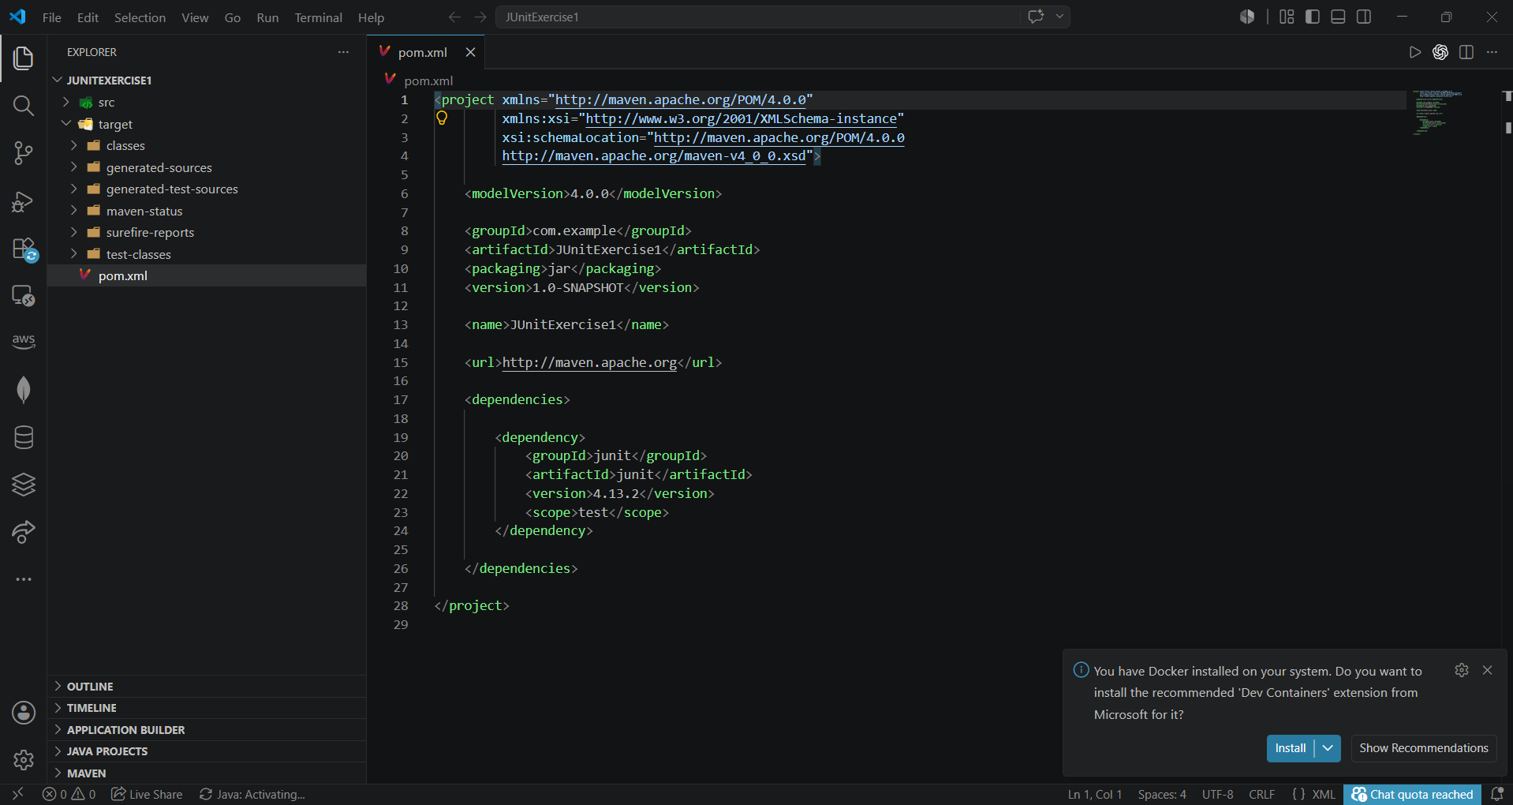

Step 3: Project Structure
The Maven project structure consists of:
JUnitExercise1
│
├── pom.xml
│
└── src
├── main
│ └── java
│ └── com.example
│ └── App.java
│
└── test
└── java
└── com.example
└── AppTest.java
Screenshot 2:
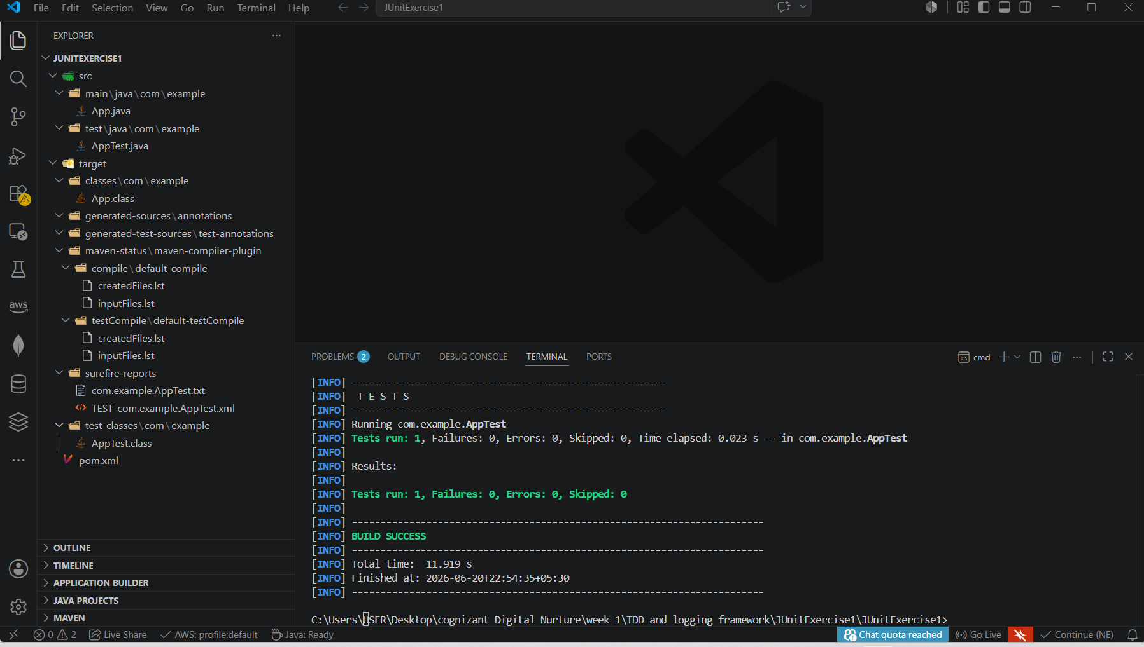

Step 4: Create a Test Class
A test class named AppTest.java was created inside the src/test/java directory.
Example:
package com.example;

import org.junit.Test;
import static org.junit.Assert.*;

public class AppTest {

@Test
public void testAddition() {
assertEquals(5, 2 + 3);
}
}
Screenshot 3:
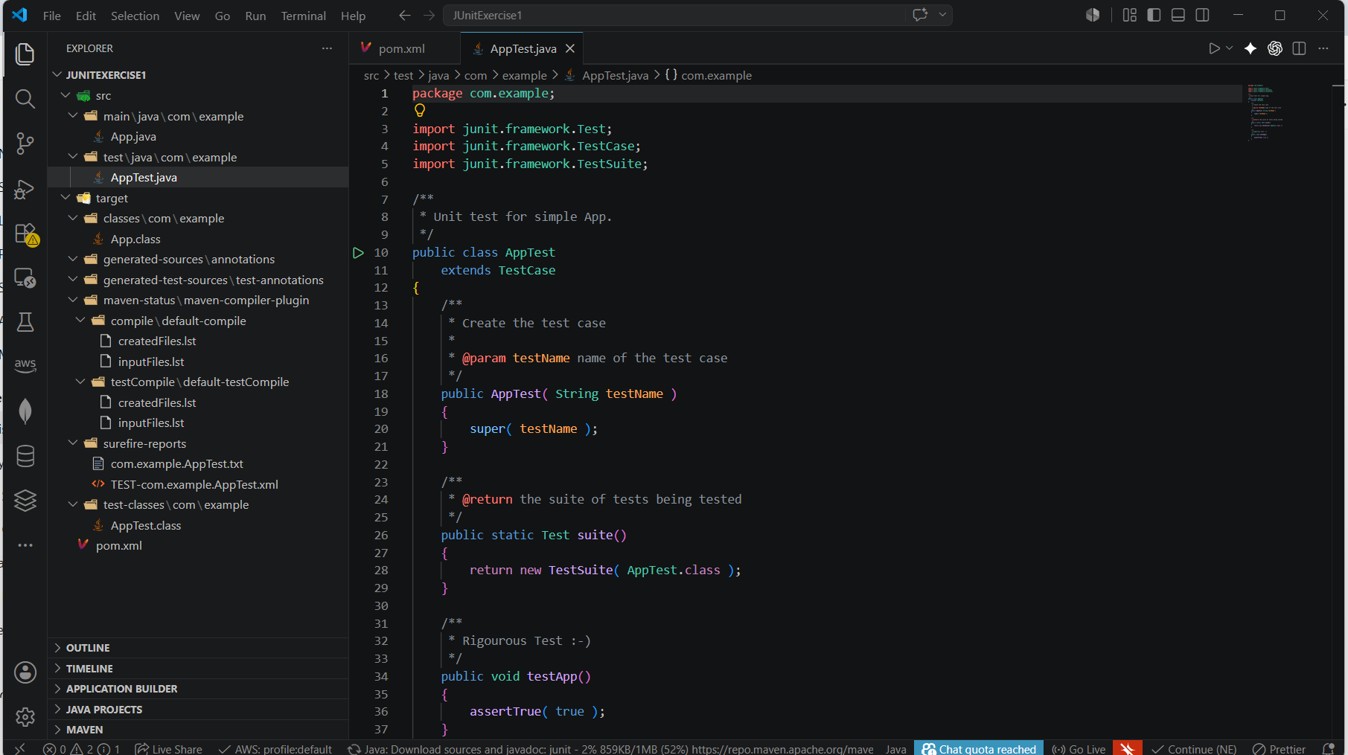

Step 5: Execute Test Cases
The Maven test command was executed:
mvn test
The build was completed successfully and the test case passed.

Output
The test case executed successfully and Maven reported:
Tests run: 1
Failures: 0
Errors: 0
BUILD SUCCESS
Screenshot 4:


Result
JUnit 4.13.2 was successfully configured in the Maven project. A test class was created and executed successfully using Maven, demonstrating the basic setup of JUnit for unit testing in Java applications.

Conclusion
This exercise provided practical experience in setting up JUnit within a Maven-based Java project. The successful execution of test cases confirmed that the testing framework was properly configured and ready for future unit testing activities.

Exercise 3: Assertions in JUnit
Aim
To understand and implement various JUnit assertions for validating test results in Java applications.

Objective
The objective of this exercise is to learn how different assertion methods provided by JUnit can be used to verify expected outcomes during unit testing.

Software Requirements
- Java Development Kit (JDK)
- Apache Maven
- Visual Studio Code
- JUnit 4.13.2

Theory
Assertions are methods provided by JUnit that help verify whether the actual result matches the expected result. If an assertion fails, the test case is marked as failed.
Common JUnit Assertions include:
- assertEquals()
- assertTrue()
- assertFalse()
- assertNull()
- assertNotNull()
These assertions are used to validate program behavior and ensure software correctness.

Procedure
Step 1: Create a Test Class
A test class named AssertionsTest.java was created inside the src/test/java directory.
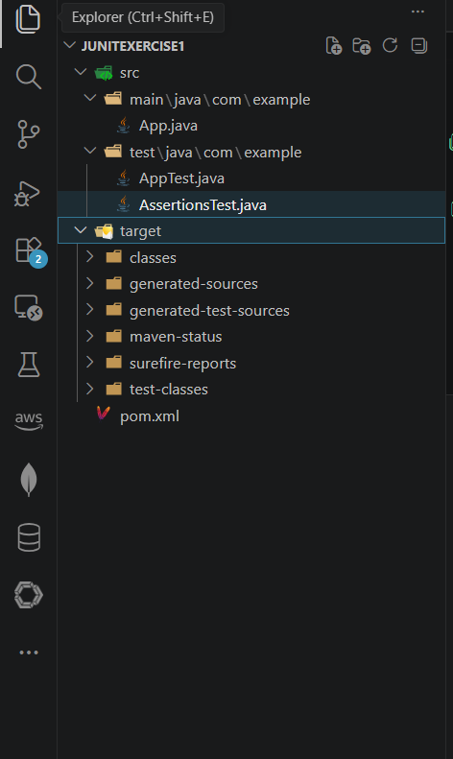
Screenshot 1:

Step 2: Implement Assertions
The test method contains different assertions to verify arithmetic operations, boolean conditions, and object references.
Assertions Used:
- assertEquals()
- assertTrue()
- assertFalse()
- assertNull()
- assertNotNull()
Screenshot 2:
Insert screenshot showing the complete source code of AssertionsTest.java.
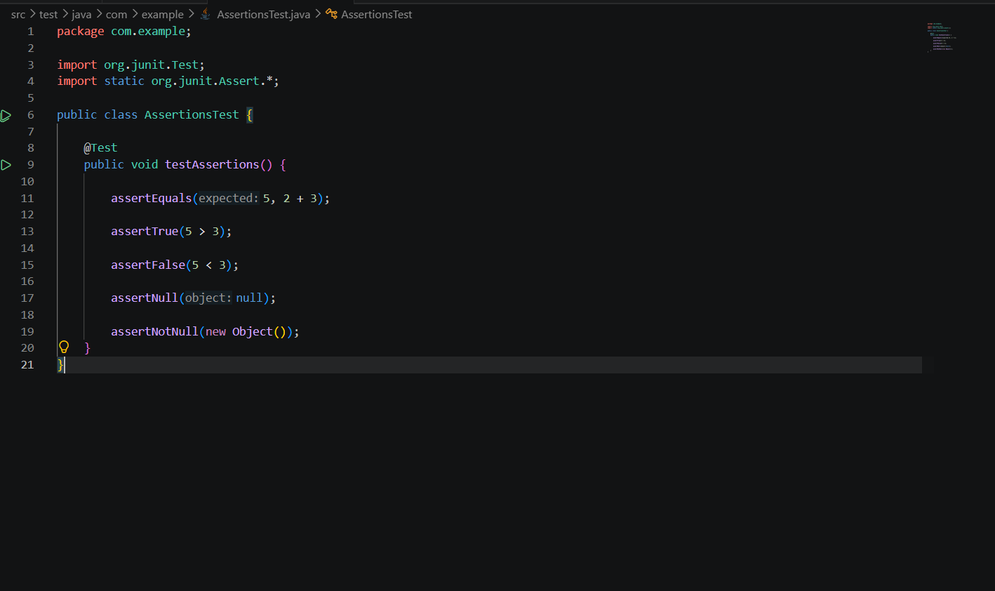

Step 3: Execute Test Cases
The Maven test command was executed:
mvn test
JUnit executed all assertions successfully.
Screenshot 3:
Insert screenshot showing the terminal command mvn test.
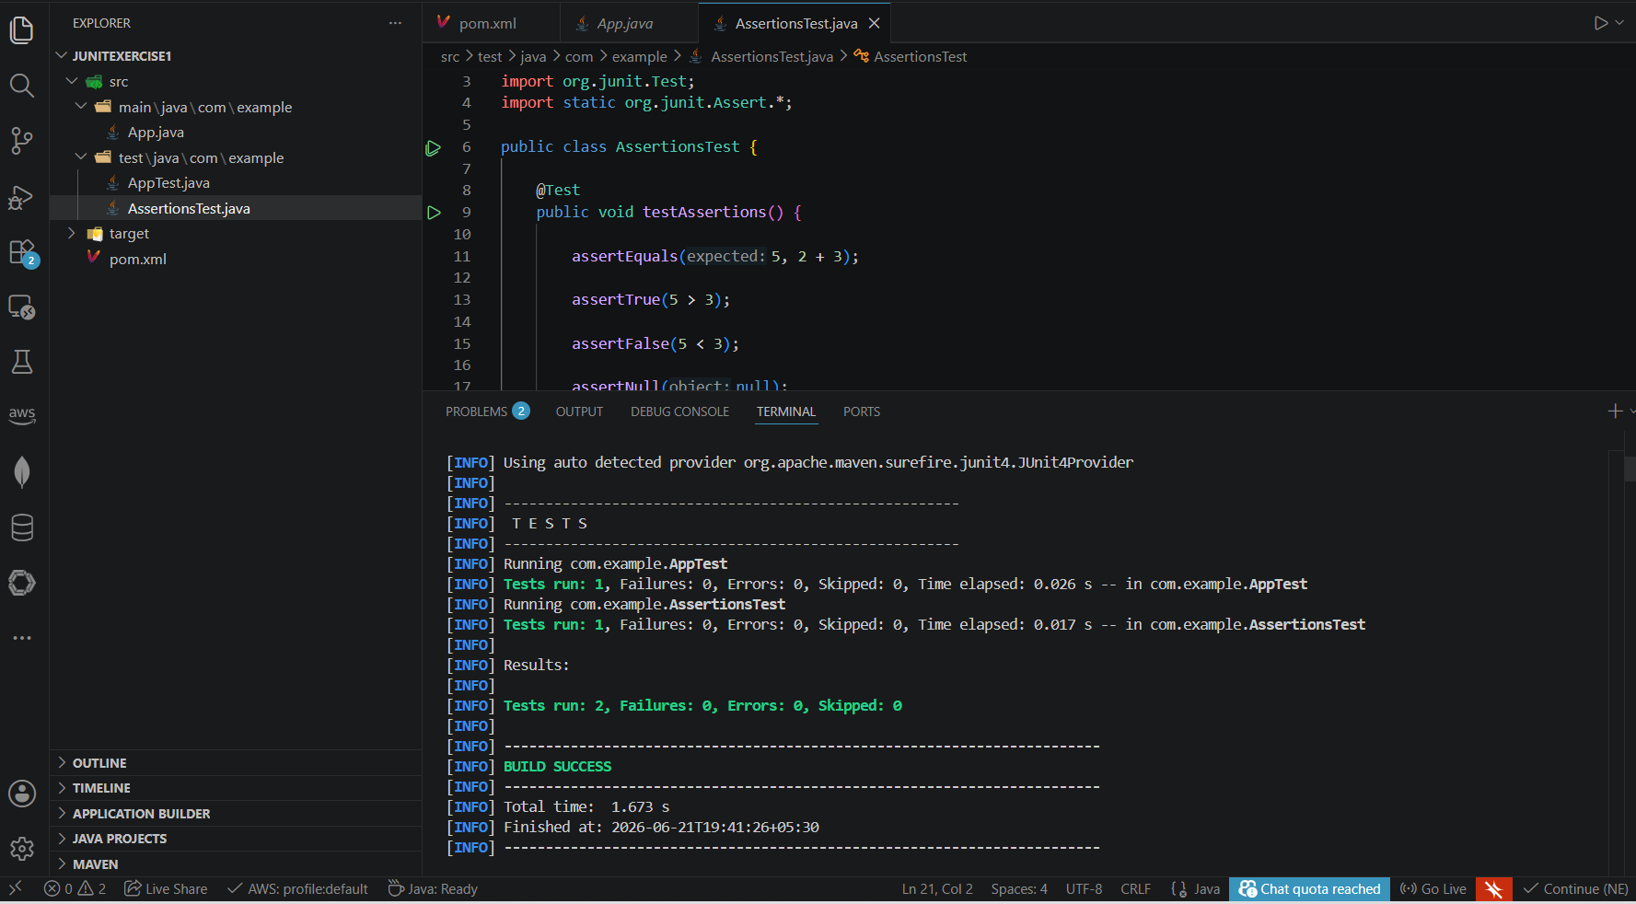

Output
The test execution completed successfully.
Output:
Tests run: 1
Failures: 0
Errors: 0
BUILD SUCCESS
Screenshot 4:
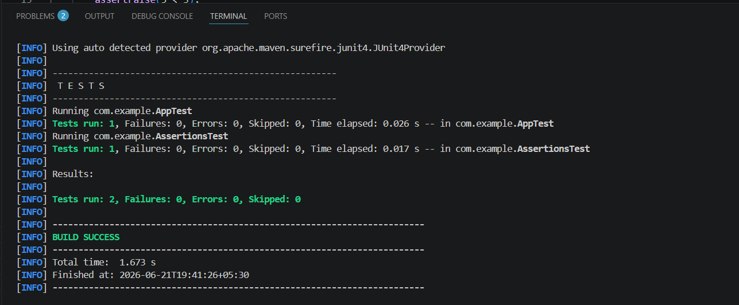

Result
The JUnit assertions were successfully implemented and executed. All assertions passed, confirming the correctness of the test conditions.

Conclusion
This exercise demonstrated the use of various JUnit assertion methods for validating expected results. Assertions are an essential part of unit testing as they help verify application behavior and ensure software quality.

